A project report on

**SMART SECURITY SYSTEM OF A GODOWN**

Submitted in partial fulfilment of the requirement for the degree of

“BACHELOR OF COMPUTER APPLICATIONS”

IN

“COMPUTER NETWORKS”

BY

**Kumari Priyanshu(0221bca075)-** Group Leader

**Nutan Singh(0221bca073)**

**Khushi Jaiswal(0221bca046)**

**Kiran Singh(0221bca074)**

Under the Supervision of

**Assist.prof Saurabh Singh**

(PC and professor)



DEPARTMENT OF INFORMATION TECHNOLOGY

OF DOON BUSINESS SCHOOL

DEHRADUN,UTTARAKHAND

15th Dec,2023

**Submitted to**

**HNBGU, Srinagar**

**DOON BUSINESS SCHOOL**

PROJECT CERTIFICATE

This is to certify that the project report on “**SMART SECURITY OF A WAREHOUSE**” submitted to HNBGU, Srinagar, in partial fulfilment of the requirement for the award of the degree of BACHELOR OF COMPUTER APPLICATIONS(BCA),is original work carried out by our team.

Under the supervision of the Assist Prof.Sauarbh Singh.

The matter embodied in this project is genuine work done by team and has not been submitted whether to this university for the fulfilment of the requirement of any course of study.

Date:

[kumaripriyanshu.bca22@doonbucsinessschool.com](mailto:kumaripriyanshu.bca22@doonbucsinessschool.com)

[nutansingh.bca22@doonbusinessschool.com](mailto:nutansingh.bca22@doonbusinessschool.com)

[khushijaiswal.bca22@doonbusinessschool.com](mailto:khushijaiswal.bca22@doonbusinessschool.com)

[kiransingh.bca22@doonbusinessschool.com](mailto:kiransingh.bca22@doonbusinessschool.com)

Verified by the supervisor

Assit Prof.Saurabh Singh sign__________

Date:

ACKNOWLEDGEMENT

This major project is the result of the contribution of many mind. We would like to acknowledge and thank my project guide Assist Prof.Saurabh Singh for his valuable support and guidance. He guided me through the process from conception and till the completion of this project. We would also like to thanks my class coordinator Assist Prof.Saurabh Singh.

We very thankful for the open-handed support extended by many people. While no list would be complete, it is our pleasure to acknowledge the assistance of the team members who provided encouragement, knowledge and constructive suggestions.

Kumari Priyanshu 0221bca075

Nutan Singh 0221bca073

Khushi Jaiswal 0221bca046

Kiran Singh 0221bca074

CERTIFICATE FROM PROJECT GUIDE

This is certify that this Major Project entitled “SMART SECURITY SYSTEM OF A GODOWN” submitted in partial fulfilment of the requirements for the award of the degree of Bachelor of Computer Application(BCA) in session (years 2023-24) to the Hemvati Nandan Bahuguna university, done by Kiran Singh is an authentic work carried out by them at “Doon Business School” under myguidance . The matter and Software embodied in this project work has not been submitted earlier for the award of any degree to the best of my knowledge and

belief.

Signature of BCA teacher

(Project Guide)

**ABSTRACT**

The expansion of Internet connectivity into tangible objects and ordinary objects is known as the Internet of things, or IOT. These devices are embedded with electronics, Internet connectivity, and other hardware components. They may be remotely monitored and controlled, as well as communicate and interact with others via the Internet. IOT is utilised in the mining sector to optimise productivity and costs, enhance safety protocols, and meet artificial intelligence requirements.

The development of the Internet of Things for electrical gadgets and uses has drawn individuals into the networked world, particularly the younger population. One application that is in great demand is the smart home. Cybersecurity problems are also increasing. Many users are unknowingly exposed to security risks as a result of their connectivity. This study uses Packet Tracer Simulation Software to offer a security analysis of the smart home environment. Version 7.1 of the Cisco Packet Tracer software configures a testbed for a basic smart home setup, complete with devices, appliances, and a security system. The network and application layers were used to simulate potential vulnerabilities. Index terms- Iot(Internet of Things),Smart security, Picking slot, Reception slot, etc.

**TABLE OF CONTENTS**

▪ Title Page

▪ Project Certificate

▪ Acknowledgement

▪ Self Certificate

▪ Certificate for Project Guide

▪ Table of Contents

**1.0 Introduction**

1.1 What is cisco packet tracer

1.2 Smart Godown Setup

1.3 Smart Godown using Cisco Packet Tracer

1.4 Development of Safe Godown

**2.0 Literature Review**

2.1 Establishing connection between Network Device and Smartphone

2.2 Connecting all End Devices to the Home gateway

**3.0 Goals and Objectives**

3.1 Conditions

3.2 Purpose

**4.0 Structure and Properties (Architecture)**

4.1 Components of the System

4.2 Interaction between components

**5.0 Conclusion and Scope of Future Work**

5.1 Conclusion

5.2 Scope of Future Work

**1.0 INTRODUCTION**

1.1 What is Cisco Packet Tracer?

1. Cisco Packet Tracer is Cisco's simulation software. It can be used to create complicated
2. network typologies, as well as to test and simulate abstract networking concepts. It acts as
3. a playground for you to explore networking and the experience is very close to what you
4. see in computer networks
5. Cisco Packet Tracer is Cisco's simulation software. It can be used to create complicated
6. network typologies, as well as to test and simulate abstract networking concepts. It acts as
7. a playground for you to explore networking and the experience is very close to what you
8. see in computer networks
9. Cisco Packet Tracer is Cisco's simulation software. It can be used to create complicated
10. network typologies, as well as to test and simulate abstract networking concepts. It acts as
11. a playground for you to explore networking and the experience is very close to what you
12. see in computer networks
13. Cisco Packet Tracer is Cisco's simulation software. It can be used to create complicated
14. network typologies, as well as to test and simulate abstract networking concepts. It acts as
15. a playground for you to explore networking and the experience is very close to what you
16. see in computer networks
17. Cisco Packet Tracer is Cisco's simulation software. It can be used to create complicated
18. network typologies, as well as to test and simulate abstract networking concepts. It acts as
19. a playground for you to explore networking and the experience is very close to what you
20. see in computer networks

Cisco Packet Tracer is Cisco's simulation software. It can be used to create complicated network typologies, as well as to test and simulate abstract networking concepts. It acts as a playground for you to explore networking and the experience is very close to what you see in computer networks.

Features of Cisco Packet Tracer:

* A multi-user system that enables numerous people to join different topologies over a computer network is supported by Cisco Packet Tracer.
* 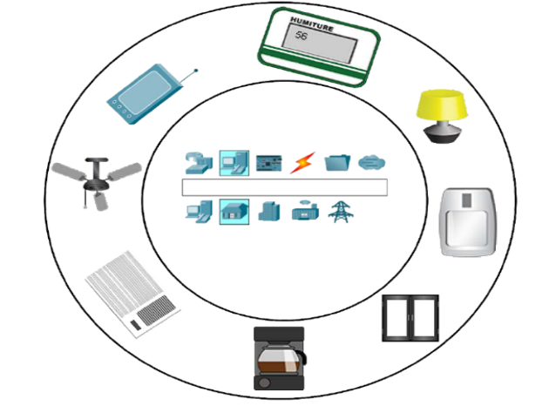With Packet Tracer, instructors may create activities that students can complete.
* It is accessible from anywhere at any time and allows users to replicate the Cisco router settings.
* It is accessible on an infinite number of devices.
* Offers a dynamic and self-directed setting.

1.3 Smart Godown using Cisco Packet Tracer:

The Smart Godown consist of the opportunity modernization of the smart learning to improve the smart devices about this part some Literature review were provided.

1.4 Development of Safe Godown:

Four Ethernet ports and a wireless access point with the "**Home Gateway"** service set identifier (SSID) are features of the home gateway. Using the config menu on each device, all of the devices are connected to the gateway; the gateway name needs to be entered. All sets of devices that need to be managed in a home gateway can have this done again. The list of devices linked to the home gateway is shown in the IP Configuration menu. All of the devices are controlled via the smartphone.

The Cisco Packet Tracer Interface offers built-in network device addition capabilities.

1.2 Smart Godown Setup:

* Requirements:
* Wireless Network Device i.e
* Home Gateway
* End Devices such as
* Smartphone
* Webcam
* Fan
* Window
* Door
* Motor Detector

**2.0 LITERATURE REVIEW**

2.1 Establishing connection between Network Device and Smartphone:

For Establishing Connection we need to setup wireless authentication to the router as three options such as,

▪ Disabled i.e. Zero Security

▪ WEP

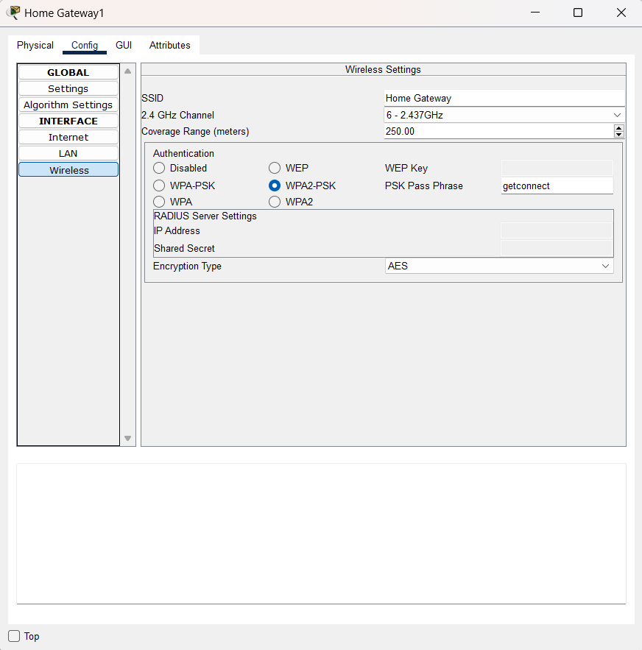 ▪ WPA2

If the security is set to disable, Copy SSID from network device and paste it in smartphone

config’s SSID , as shows in Fig 1.2

If the security is set to disable, Copy SSID from network device and paste it in smartphone

config’s SSID , as shows in Fig 1.2

Fig 1.1

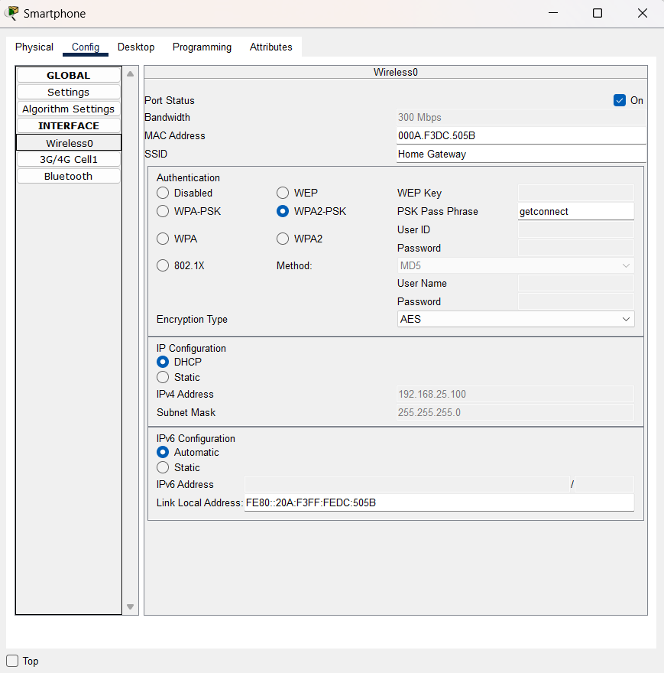If the security is set to disable, Copy SSID from network device and paste it in smartphone config’s SSID , as shows in Fig 1.2

Fig 1.3

As result we established connection between Smartphone and home gateway.

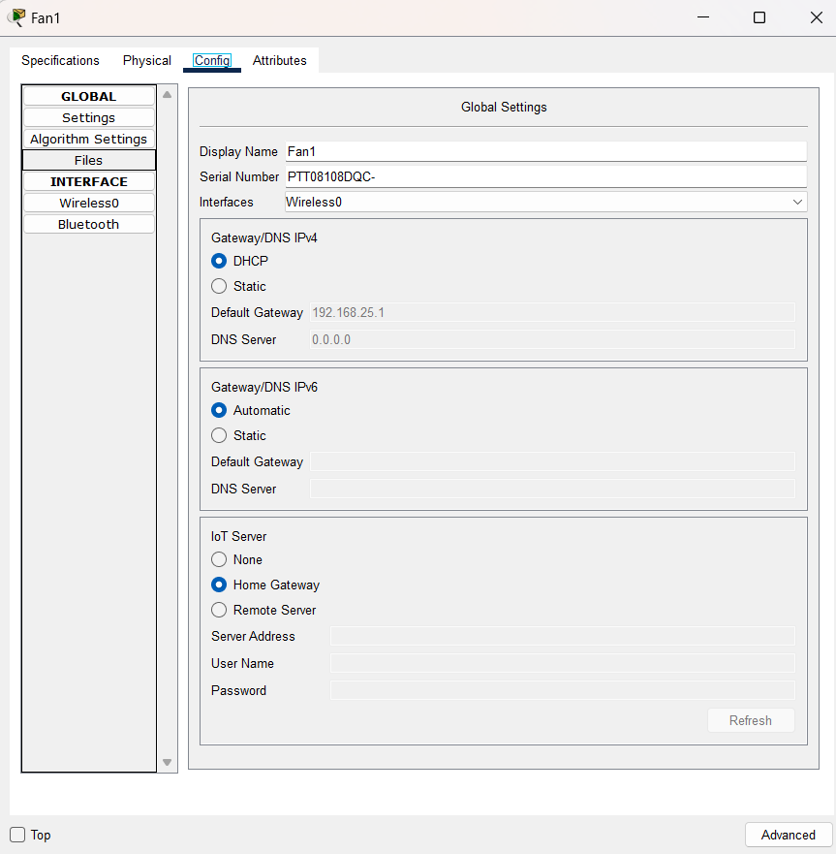2.2 Connecting all End Devices to the Home gateway:

For connecting end devices, we need to setup our devices first as shown in Fig 1.2 Steps :

▪ Click on end device

▪ Go to Advance

Then go to I/O Config ▪ Select PT-IOT-NM-1W as Network Adapter, as shown in Fig 1.4

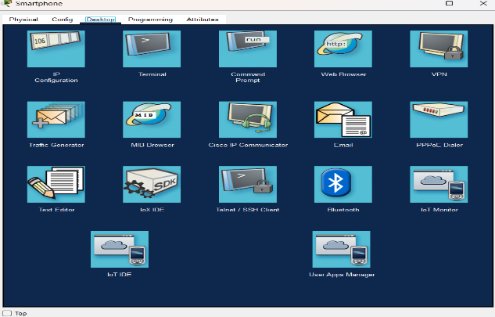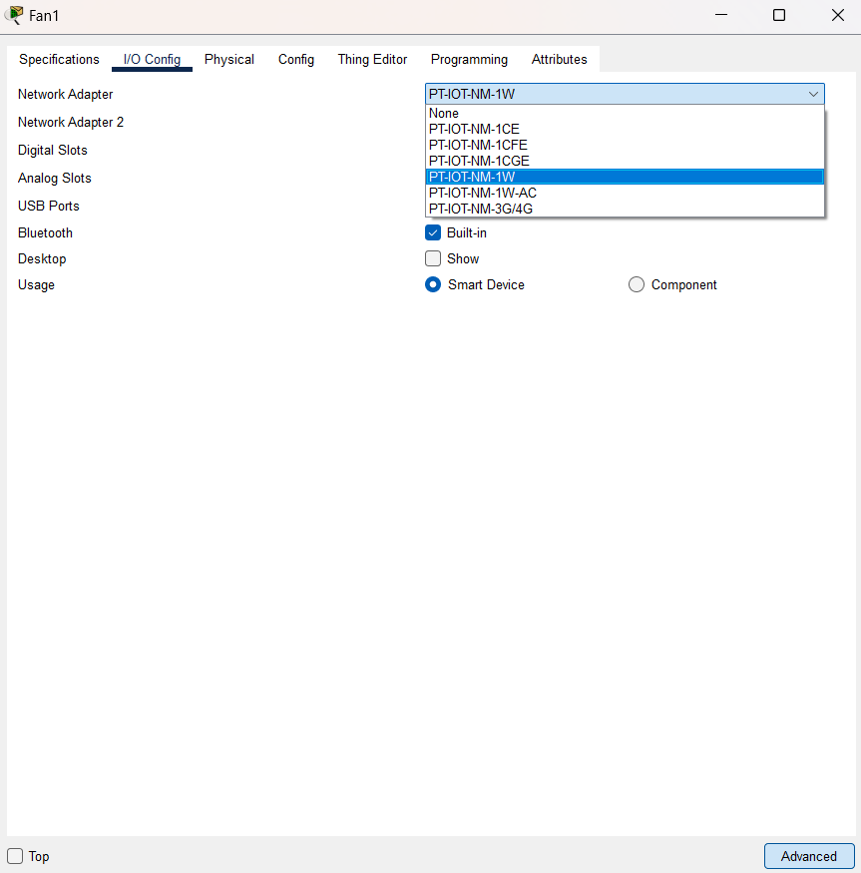

Fig 1.4

* After Selecting Network Adapter, Go to Config
* Inside Config, Go to Setting
* 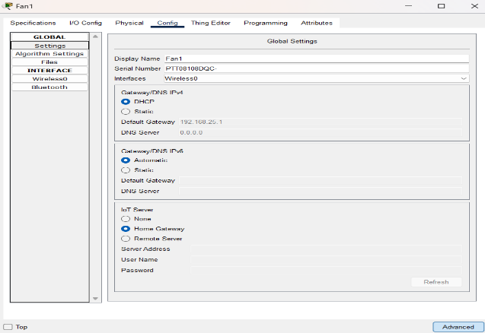Scroll Down and Select HomeGateway, as shown in Fig1.2

Fig 1.5

* Revise this steps to all the end devices for connecting to HomeGateway.
* After connecting all end devices it may look like , as shown in Fig 1.4
* Testing For Controlling the IOT devices, we need to access it through SmartPhone Steps :
* Click on SmartPhone
* Go to Desktop
* Click on IoT Monitor as shown in Fig 1.5

Fig 1.6

* Click on IoT Monitor
* 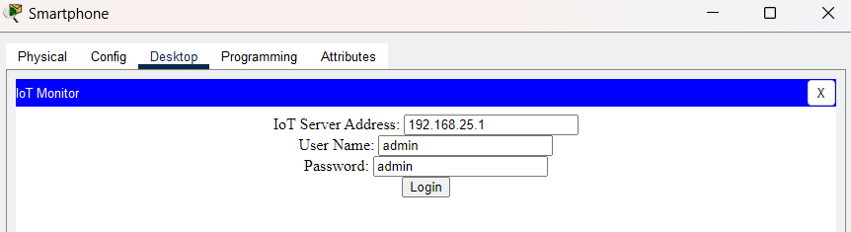The screen should Pop-Up, as shown in Fig 1.6

Fig 1.7

* The Details are pre-field no need to change it.
* Hit Login Button
* 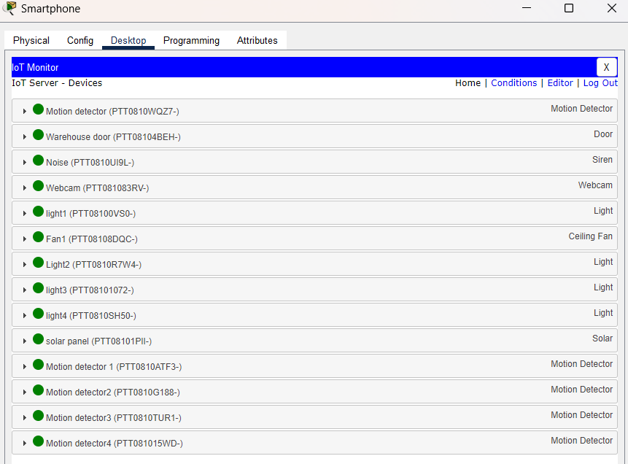The IOT devices list will be display, as shown in Fig 1.7

Fig 1.8

**3.0 Goals and Objectives**

3.1 Conditions

* Controlling Fan Speed with Smartphone
* Click on fan and change status as high or low
* As you can see the fan indicates with the two borders that fan is at high speed

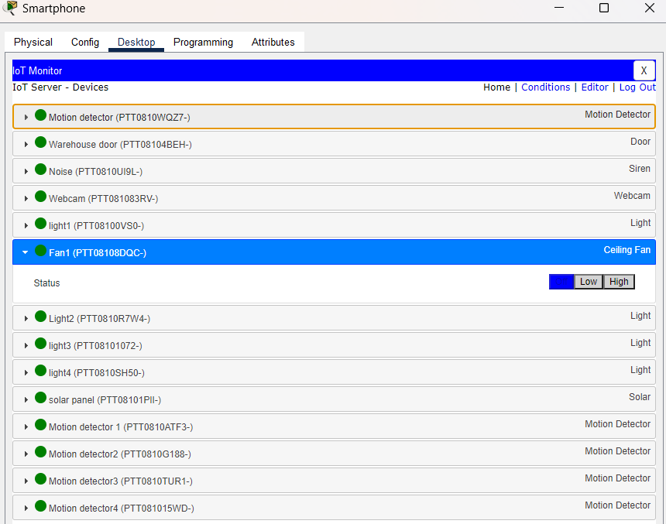

Fig 1.9

Switching On and Off lamp light with SmartPhone.

* Click on Fan and change status to Dim or On
* 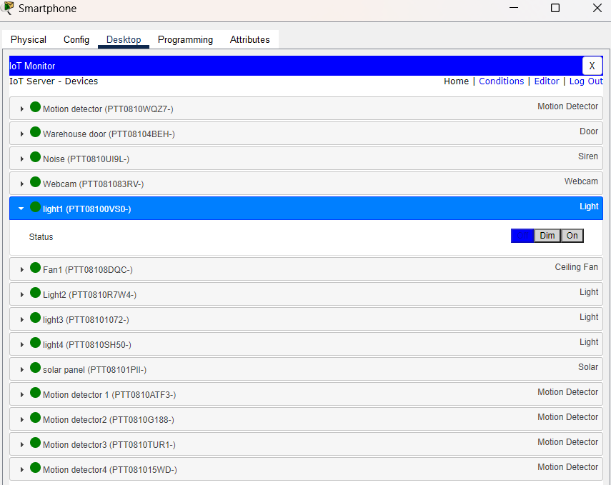As you can see the ligh of lamp has turned on

Fig 1.10

Opening and Closing Door with SmartPhone.

* Click on Door and click on red indicator
* As result the Door has been opened successfully
* 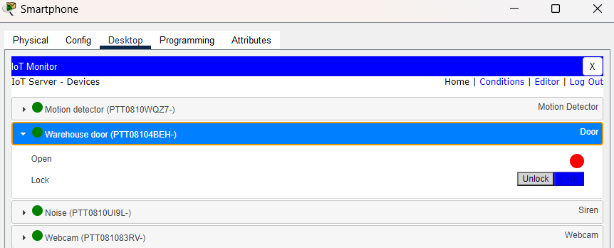(tip : Red indicates the Door is closed and green indicated the Door is opened)

Fig 1.11

* This is how you can control all the IOT End devices with the help of Network Device and SmartPhone.

3.1 PURPOSE

The Smart Security for a Godown is Design to provide enhanced security and protection for the store goods and assets. It utilises advanced technologies and automation to monitor and control access, detect and prevent unauthorised entry and ensure the safety of the Godown premises.

Benefit of implementing the system

Implementing the smart security system brings several benefits to the Godown operations and management:

* Enhanced security-The system provides real time monitoring and alerts, ensuring prompt response to any security breaches and incidents
* Improved access control-Access to the Godown premises can be managed and restricted based on authorized personnel, reducing the risk of unauthorised access.
* Efficient inventory management- The system allows for accurate tracking and monitoring of the stored goods, inabling better inventory control and reducing losses of theft.
* Cost savings:By preventing theft, minimising losses and optimising inventory management, the smart security system helps in reducing overall costs and improving profitability.

**4.0 STRUCTURE AND PROPERTIES**

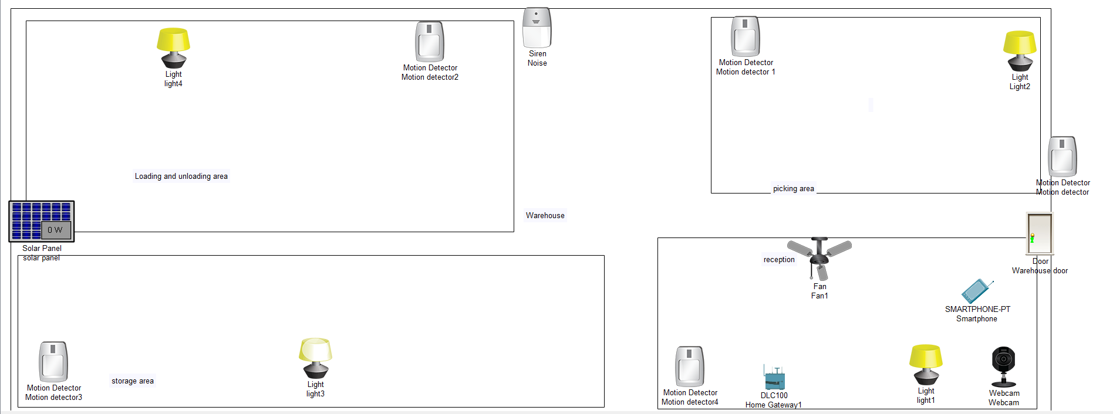SYSTEM ARCHITECTURE OF THE SMART SECURITY SYSTEM:

4.1 Components of the system:

The smart security system consists of several key components that work together to provide comprehensive security for the Godown.

* Sensors and Detectors
* Control panel
* Camera System
* Alarm System
* Network infrastructure

4.2 Interaction between components:

The sensors and Detectors continuously monitor the Godown for any unauthorized access or unusual activity. When a sensor detect something, it sends a signal to the control panel. The control panel then processes the signal and triggers the appropriate response, such as activating the alarm system on notifying security personnel.

The network infrastructure connects all the components of the system, allowing them to communicate and share information. This enables centralised monitoring and control of the security system.

The camera system provides visual surveillance of the Godown and feed live video to the control panel.

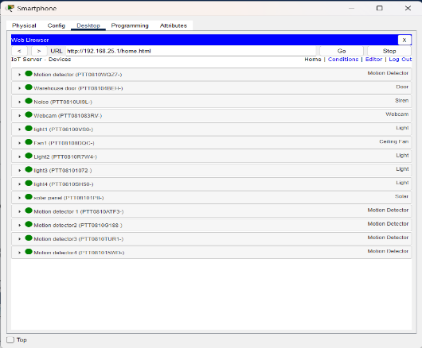

**5.0 CONCLUSION AND SCOPE OF FUTURE WORK**

5.1 Conclusion

In conclusion, the implementation of a smart security system in a warehouse using IoT devices offers numerous benefits and plays a crucial role in ensuring the safety and security of the facility.

Key Points:

* Real-time monitoring and surveillance of the warehouse premises, both indoors and outdoors.
* Immediate detection and alerting of any unauthorized access or suspicious activities.
* Integration with other security systems and devices, such as alarms and access control systems.
* Efficient management and analysis of security data, enabling proactive measures to prevent potential threats.
* The smart security system not only enhances the overall security of the warehouse but also provides valuable insights for optimizing operations and improving efficiency.
* By investing in this advanced technology, warehouse owners and operators can enjoy peace of mind, minimize risks, and protect their valuable assets.

5.2 Scope of future work

Implementing a smart security system in a warehouse can provide numerous benefits, including:

* Real-time monitoring of the premises, allowing for quick response to potential security threats.
* Surveillance of the warehouse premises, including access points and storage areas, to prevent unauthorized access and theft.
* Automated alerts and notifications in case of any security breaches or suspicious activity.